|  |
| --- |
| IFMR RURAL FINANCE |
| Screening |
|  |
| **IFMR Rural Finance** |
| **10/19/2016** |

|  |
| --- |
|  |

Contents

Process Diagram 3

1. Stage definition 4

2. Stage-role access 4

3. Screening review Queue 4

3.1 UI specification 4

3.2 Screenshot 5

3.3 Functional requirements 6

3.4 Upload 6

3.5 Download 6

3.6 Reports 6

4. Reviewing Screening stage data 7

4.1 UI requirements 7

4.2 Screenshots 21

4.3 Functional requirements 43

4.6 Downloads 43

4.7 Reports 43

# Process Diagram



# Stage definition

|  |  |
| --- | --- |
| **Stage** | **Description** |
| Screening Review Queue | The Hub Manager selects a profile from the screening stage |
| Customer View | The Hub Manager reviews data and submits the same Application stage on successful review or send back to screening stage in case of any deviations. |

# Stage-role access

|  |  |
| --- | --- |
| **Stage** | **Applicable Role** |
| Screening Review Queue | Hub Manager |
| Customer View | Hub Manager |

# Screening review Queue

## UI specification

|  |  |  |  |  |
| --- | --- | --- | --- | --- |
| **Field name** | **Section** | **Data Type** | **Attribute** | **Population logic** |
| S. No. | Hub Manager Queue | Numeric |  |  |
| Applicant Name | Hub Manager Queue | Text | Sort/search | From screening stage |
| Business Name | Hub Manager Queue | Alphanumeric | Sort/search | From screening stage |
| URN No | Hub Manager Queue | Alphanumeric | Sort/search | From screening stage |
| Area | Hub Manager Queue | Text | Sort/search | From screening stage |
| City/Village/ Town | Hub Manager Queue | Text | Sort/search | From screening stage |
| Pincode | Hub Manager Queue | Numeric |  | From screening stage |

## Screenshot

* + 1. Search Page

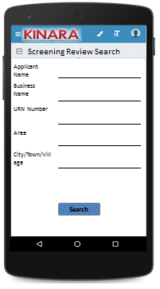

* + 1. Application Queue

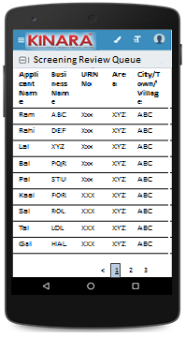

## Functional requirements

Hub Manager logs in

* The Hub Manager opens the process dash board, and clicks on Screening Review Queue
* If the Hub Manager performs a search without selecting any parameter, then all cases with status ‘Pending for Screening Review’ to be displayed in a tabular format.
* If the Hub Manager searches with ‘Applicant name’, ‘Business name’ or ‘URN no’, then all matching records that are ‘Pending for Screening Review’ to be displayed in a tabular format.
* The Hub Manager can **search and sort** the profiles based on the following parameters: URN no, Applicant Name, Business Name, Area, City/Village/Town.
* The Hub Manager then selects a profile from the application queue. The queue table should have applicant name, business name, URN No, Area, City/Town/Village as column names.
* All the columns will have **sorting** facility.

## Upload

-NA-

## Download

-NA-

## Reports

-NA-

# Reviewing Screening stage data

## UI requirements

|  |  |  |  |  |  |  |  |
| --- | --- | --- | --- | --- | --- | --- | --- |
| **Entity** | **Tab** | **Sub tab** | **Fields** | Field Value | **Mandatory** | **Conditional Mandatory** | **Remarks** |
| **Financial Summary** | **Risk Score** |  | Screening Score | Numeric |  |  |  |
| **CB Check Report** |  |  |  |  |  |  |
| **Applicant** | **Applicant Profile** | **KYC Details** | Aadhar No | Numeric | Yes |  | From Screening |
| Document Capture | Upload | Yes |  | From Screening |
| Pan Number | Alpha numeric | Yes |  | From Screening |
| Document Capture | Upload | Yes |  | From Screening |
| ID Type | Dropdown |  |  | From Screening |
| ID No | Alpha numeric |  | Yes | From Screening |
| Valid Upto | Date |  | Yes | From Screening |
| Document Capture | Upload |  | Yes | From Screening |
| **Applicant Details** | Title* | Auto populated/Text | Yes |  | From Screening |
| Name* | Auto populated/Text | Yes |  | From Screening |
| Gender* | Auto populated/Text | Yes |  | From Screening |
| Date Of birth* | Auto populated/Date | Yes |  | From Screening |
| Age | Auto populated |  |  | From Screening |
| Father's Name* | Auto populated/Text | yes |  | From Screening |
| Educational Level* | Dropdown | Yes |  | From Screening |
| Religion* | Dropdown | Yes |  | From Screening |
| Mobile No* | Numeric | Yes |  | From Screening |
| Alternative Mobile No. | Numeric |  |  | From Screening |
| WhatsApp Mobile No. | Numeric |  |  | From Screening |
| Email ID | Alphanumeric, spl charac |  |  | From Screening |
| Preferred language of communication* | Dropdown | Yes |  | From Screening |
| Mothers Name | Text |  |  | From Screening |
| Marital Status* | Text | Yes |  | From Screening |
| Spouse Name | Text |  |  | From Screening |
| Relationship with Business* | Dropdown | Yes |  | From Screening |
| Business Involvement* | Dropdown | Yes |  | From Screening |
| Have you ever been a proprietor or partner of any other company | Yes, No |  |  | From Screening |
| If yes, did the business close? | Yes, No |  |  | From Screening |
| Month/Year (of business closure) | Date |  |  | From Screening |
| **Address Details** | Type Of Address | Dropdown | Yes |  | From Screening |
| Care of | text |  |  | From Screening |
| Building* | Alphanumeric, spl charac | yes |  | From Screening |
| Street | Alphanumeric, spl charac |  |  | From Screening |
| Landmark | Alphanumeric, spl charac |  |  | From Screening |
| Locality | Alphanumeric, spl charac |  |  | From Screening |
| Pincode* | Numeric | yes |  | From Screening |
| Village/Town/City* | Text | yes |  | From Screening |
| District* | Text | yes |  | From Screening |
| State* | Text | yes |  | From Screening |
| Country* | Text | yes |  | From Screening |
| Location | GPS Coordinates | Yes |  | From Screening |
| Is the Communication Address same as the Adhar Card address? | Radio Buttons | Yes |  | Yes/No From Screening |
| Line 1 | Alpha numeric | Yes |  | From Screening |
| Line 2 | Alpha numeric |  |  | From Screening |
| Area | Alpha numeric |  |  | From Screening |
| Land Mark | Alpha numeric | Yes |  | From Screening |
| Pincode | Numeric | yes |  | From Screening |
| State | Auto populated | Yes |  | From Screening |
| District | Auto populated | Yes |  | From Screening |
| City/Town/Village | Auto populated | Yes |  | From Screening |
| Landline Number | Numeric |  |  | From Screening |
| Ownership | Dropdown | Yes |  | From Screening |
| How many years are you living in present Area? | Dropdown | Yes |  | From Screening |
| How many years are you living in current Address? | Dropdown | Yes |  | From Screening |
| Is the Communication Address same as Permanent Address? | Radio Buttons | Yes |  | From Screening |
| **Liabilities** | **-** | Debt Source | dropdown |  |  | From Screening |
| Creditor's Name | Alphanumeric |  |  | From Screening |
| Loan Amount | Numeric |  |  | From Screening |
| Loan Outstanding | Numeric |  |  | From Screening |
| Loan term | Alphanumeric |  |  | From Screening |
| Monthly Instalment | Numeric |  |  | From Screening |
| No. Of instalment Paid | Numeric |  |  | From Screening |
| Purpose | dropdown |  |  | From Screening |
| **Bank Statement Details** | **-** | IFSC Code | Alphanumeric |  |  | From Screening |
| Bank Name | Alphanumeric | Yes |  | From Screening |
| Branch Name | Alphanumeric |  |  | From Screening |
| A/C name | Alphanumeric | Yes |  | From Screening |
| A/C type | Dropdown | Yes |  | From Screening |
| A/C no | Numeric | Yes |  | From Screening |
| Banking since | Date |  |  | From Screening |
| Net banking available | Radio Buttons | Yes |  | From Screening |
| Sanctioned Amount | Numeric |  | Yes | From Screening |
| Start Month | Date | Yes |  | From Screening |
| Total Deposits* | Numeric | Yes |  | From Screening |
| Total Withdrawals* | Numeric | Yes |  | From Screening |
| Balance as on 15th* | Numeric | Yes |  | From Screening |
| No of cheques bounced* | Numeric | Yes |  | From Screening |
| Bank Statement Photo | Photo Capture |  |  | From Screening |
|  |  |  |  |  |  |  |  |
| **Co-Applicant** | **Co-Applicant Profile** | **KYC Details** | Aadhar No | Numeric | Yes |  | From Screening |
| Document Capture | Upload | Yes |  | From Screening |
| Pan Number | Alpha numeric | Yes |  | From Screening |
| Document Capture | Upload | Yes |  | From Screening |
| ID Type | Dropdown |  |  | From Screening |
| ID No | Alpha numeric |  | Yes | From Screening |
| Valid Upto | Date |  | Yes | From Screening |
| Document Capture | Upload |  | Yes | From Screening |
| **Co-Applicant Details** | Title* | Auto populated/Text | Yes |  | From Screening |
| Name* | Auto populated/Text | Yes |  | From Screening |
| Gender* | Auto populated/Text | Yes |  | From Screening |
| Date Of birth* | Auto populated/Date | Yes |  | From Screening |
| Age | Auto populated |  |  | From Screening |
| Father's Name* | Auto populated/Text | Yes |  | From Screening |
| Educational Level* | Dropdown | Yes |  | From Screening |
| Religion* | Dropdown | Yes |  | From Screening |
| Mobile No* | Numeric | Yes |  | From Screening |
| Alternative Mobile No. | Numeric |  |  | From Screening |
| WhatsApp Mobile No. | Numeric |  |  | From Screening |
| Email ID | Alphanumeric, spl charac |  |  | From Screening |
| Preferred language of communication* | Dropdown | Yes |  | From Screening |
| Mothers Name | Text |  |  | From Screening |
| Marital Status* | Text | Yes |  | From Screening |
| Spouse Name | Text |  |  | From Screening |
| Relationship with Applicant | Text | Yes |  | From Screening |
|  | Relationship with Business | Dropdown | Yes |  | From Screening |
| From Screening |
| Business Involvement* | Dropdown | Yes |  | From Screening |
| Have you ever been a proprietor or partner of any other company | Radio Buttons |  |  | From Screening |
| If yes, did the business close? | Radio Buttons |  |  | From Screening |
| Month/Year (of business closure) | Date |  |  | From Screening |
| **Address Details** | Type of Address | Dropdown | Yes |  | From Screening |
| Care of | text |  |  | From Screening |
| Building* | Alphanumeric, spl charac | Yes |  | From Screening |
| Street | Alphanumeric, spl charac |  |  | From Screening |
| Landmark | Alphanumeric, spl charac |  |  | From Screening |
| Locality | Alphanumeric, spl charac |  |  | From Screening |
| Pincode* | Numeric | yes |  | From Screening |
| Village/Town/City* | Text | yes |  | From Screening |
| District* | Text | yes |  | From Screening |
| State* | Text | yes |  | From Screening |
| Country* | Text | Yes |  | From Screening |
| Location | GPS Co-ordinates | Yes |  | From Screening |
| Is the Communication Address same as the Adhar Card address? | Radio Buttons | Yes |  | From Screening |
| Line 1 | Alpha numeric | Yes |  | From Screening |
| Line 2 | Alpha numeric |  |  | From Screening |
| Area | Alpha numeric |  |  | From Screening |
| Land Mark | Alpha numeric | Yes |  | From Screening |
| Pincode | Numeric | Yes |  | From Screening |
| State | Auto populated/text | Yes |  | From Screening |
| District | Auto populated/text | Yes |  | From Screening |
| City/Town/Village | Auto populated/text | Yes |  | From Screening |
| Landline Number | Numeric |  |  | From Screening |
| Ownership | Dropdown | Yes |  | From Screening |
| How many years are you living in present Area? | Dropdown | Yes |  | From Screening |
| How many years are you living in current Address? | Dropdown | Yes |  | From Screening |
| Is the Communication Address same as Permanent Address? | Radio Buttons | Yes |  | From Screening |
| **Liabilities** | **-** | Debt Source | dropdown |  |  | From Screening |
| Creditor's Name | Alphanumeric |  |  | From Screening |
| Loan Amount | Numeric |  |  | From Screening |
| Loan Outstanding | Numeric |  |  | From Screening |
| Loan term | Alphanumeric |  |  | From Screening |
| Monthly Installment | Numeric |  |  | From Screening |
| No. Of instalment Paid | Numeric |  |  | From Screening |
| Purpose | dropdown |  |  | From Screening |
| **Bank Statement Details** | **-** | IFSC Code | Alphanumeric |  |  | From Screening |
| Bank Name | Alphanumeric | Yes |  | From Screening |
| Branch Name | Alphanumeric |  |  | From Screening |
| A/C name | Alphanumeric | Yes |  | From Screening |
| A/C type | dropdown | Yes |  | From Screening |
| A/C no | Numeric | Yes |  | From Screening |
| Banking since | Date |  |  | From Screening |
| Net banking available | Radio Buttons | Yes |  | From Screening |
| Sanctioned Amount | Numeric |  | yes | From Screening |
| Start Month | Date | Yes |  | From Screening |
| Total Deposits* | Numeric |  |  | From Screening |
| Total Withdrawals* | Numeric |  |  | From Screening |
| Balance as on 15th* | Numeric |  |  | From Screening |
| No of cheques bounced* | Numeric |  |  | From Screening |
|  | | | | | | | |
| **Guarantor** | **Guarantor Profile** | **KYC Details** | Aadhar No | Numeric | Yes |  | From Screening |
| Document Capture | Upload | Yes |  | From Screening |
| Pan Number | Alpha numeric | Yes |  | From Screening |
| Document Capture | Upload | Yes |  | From Screening |
| ID Type | Dropdown |  |  | From Screening |
| ID No | Alpha numeric |  | Yes | From Screening |
| Valid Upto | Date |  | Yes | From Screening |
| Document Capture | Upload |  | Yes | From Screening |
| **Guarantor Details** | Title* | Auto populated/Text | Yes |  | From Screening |
| Name* | Auto populated/Text | Yes |  | From Screening |
| Gender* | Auto populated/Text | Yes |  | From Screening |
| Date Of birth* | Auto populated/Date | Yes |  | From Screening |
| Age | Auto populated |  |  | From Screening |
| Father's Name* | Auto populated/Text | yes |  | From Screening |
| Educational Level* | Dropdown | Yes |  | From Screening |
| Religion* | Dropdown | Yes |  | From Screening |
| Mobile No* | Numeric | Yes |  | From Screening |
| Alternative Mobile No. | Numeric |  |  | From Screening |
| WhatsApp Mobile No. | Numeric |  |  | From Screening |
| Email ID | Alphanumeric, spl charac |  |  | From Screening |
| Preferred language of communication* | Dropdown | Yes |  | From Screening |
| Mother’s Name | Text |  |  | From Screening |
| Marital Status | Text | Yes |  | From Screening |
| Spouse Name | Text |  |  | From Screening |
| Relationship with Applicant | Text | Yes |  | From Screening |
| Business Involvement* | Dropdown | Yes |  | From Screening |
| Have you ever been a proprietor or partner of any other company | Radio Buttons |  |  | From Screening |
| If yes, did the business close? | Radio Buttons |  |  | From Screening |
| Month/Year (of business closure) | Date |  |  | From Screening |
| **Address Details** | Type Of Address | Dropdown | Yes |  | From Screening |
| Care of | Text |  |  | From Screening |
| Building* | Alphanumeric, spl charac | yes |  | From Screening |
| Street | Alphanumeric, spl charac |  |  | From Screening |
| Landmark | Alphanumeric, spl charac |  |  | From Screening |
| Locality | Alphanumeric, spl charac |  |  | From Screening |
| Pincode* | Numeric | yes |  | From Screening |
| Village/Town/City* | Text | yes |  | From Screening |
| District* | Text | yes |  | From Screening |
| State* | Text | yes |  | From Screening |
| Country* | Text | yes |  | From Screening |
| Location | GPS Coordinates | Yes |  | From Screening |
| Is the Communication Address same as the Adhar Card address? | Radio Buttons | Yes |  | From Screening |
| Line 1 | Alpha numeric | Yes |  | From Screening |
| Line 2 | Alpha numeric |  |  | From Screening |
| Area | Alpha numeric |  |  | From Screening |
| Land Mark | Alpha numeric | Yes |  | From Screening |
| Pincode | Numeric | Yes |  | From Screening |
| From Screening |
| From Screening |
| State | Auto populated | Yes |  | From Screening |
|  | District | Auto populated | Yes |  | From Screening |
| City/Town/Village | Auto populated | Yes |  | From Screening |
| Landline Number | Numeric |  |  | From Screening |
| Ownership | Dropdown | Yes |  | From Screening |
| How many years are you living in present Area? | Dropdown | Yes |  | From Screening |
| How many years are you living in current Address? | Dropdown | Yes |  | From Screening |
| Is the Communication Address same as Permanent Address? | Radio Buttons | Yes |  | From Screening |
| **Business** | **Business Profile** | **Business Details** | Referred by | Dropdown | Yes |  | From Screening |
| Referred Name | Text |  | Yes (Based on the dropdown) | From Screening |
| Business Name | Text | Yes |  | From Screening |
| Business type | Dropdown | Yes |  | From Screening |
| Business Activity | Dropdown | Yes |  | From Screening |
| Business Sector | Dropdown | Yes |  | From Screening |
| Business Sub sector | Dropdown | Yes |  | From Screening |
| ITR available ? | Radio Buttons |  |  | From Screening |
| Business Operating since | Date |  |  | From Screening |
| Is the Business Registered? | Radio Buttons | Yes |  | From Screening |
| Business Registration Type | Dropdown |  | Yes | From Screening |
| From Screening |
| Business Registration Proof No | AlphaNumeric |  | Yes | From Screening |
| Business Registration Date | Date |  | Yes | From Screening |
| Valid Upto | Date |  | Yes | From Screening |
| Document Capture | Upload |  | Yes | From Screening |
| Add Business Regn Type button |  |  |  | From Screening |
| Constitution | Dropdown | Yes |  | From Screening |
| If partnership, how many total partners | Dropdown |  | Yes | From Screening |
| Has anyone else been a partner of your present business | Radio Buttons |  |  | From Screening |
| If yes, when was that partnership dissolved? | Date |  | Dissolution Agreement required | From Screening |
| **Address Details** | Line 1 | Alpha numeric | Yes |  | From Screening |
| Line 2 | Alpha numeric |  |  | From Screening |
| Pin Code (Search Option) | Numeric | Yes |  | From Screening |
| Land Mark | Text | Yes |  | From Screening |
| State (Auto populate) | Auto populated | Yes |  | From Screening |
| District(Auto populate) | Auto populated | Yes |  | From Screening |
| City/Village | Auto populated | Yes |  | From Screening |
| Location (GPS) | GPS co-ordinates | yes |  | From Screening |
| Landline Phone | Numeric | Yes |  | From Screening |
| Ownership | dropdown | Yes |  | From Screening |
| How many years business in present Area ? | dropdown | Yes |  | From Screening |
| How many years business in current address? | dropdown | Yes |  | From Screening |
| From Screening |
| **Liabilities** |  | Debt Source | dropdown |  |  | From Screening |
| Creditor's Name | Alphanumeric |  |  | From Screening |
| Loan Amount | Numeric |  |  | From Screening |
| Loan Outstanding | Numeric |  |  | From Screening |
| Loan term | Alphanumeric |  |  | From Screening |
| Monthly Installment | Numeric |  |  | From Screening |
| No. Of instalment Paid | Numeric |  |  | From Screening |
| Purpose | dropdown |  |  | From Screening |
| **Bank Statement** | **-** | IFSC Code | Alphanumeric |  |  | From Screening |
| Bank Name | Alphanumeric | Yes |  | From Screening |
| Branch Name | Alphanumeric |  |  | From Screening |
| A/C name | Alphanumeric | Yes |  | From Screening |
| A/C type | Dropdown | Yes |  | From Screening |
| A/C no | Numeric | Yes |  | From Screening |
| Banking since | Date |  |  | From Screening |
| Net banking available | Radio Buttons | Yes |  | From Screening |
| Sanctioned Amount | Numeric |  | yes | From Screening |
| Start Month | Date | Yes |  | From Screening |
| Total Deposits* | Numeric | Yes |  | From Screening |
| Total Withdrawals* | Numeric | Yes |  | From Screening |
| Balance as on 15th* | Numeric | Yes |  | From Screening |
| No of cheques bounced* | Numeric | Yes |  | From Screening |
| No of EMI cheques bounced* | Numeric | Yes |  | From Screening |
| **Business Financials** | **-** | Monthly turnover | Numeric | Yes |  | From Screening |
| Monthly Business Expenses | Numeric |  |  | From Screening |
| Avg Monthly Net Income | Auto Calculated |  |  | From Screening |
| **Loan request** | **-** | **-** | Purpose | Dropdown | Yes |  | From Screening |
| Sub-purpose | Dropdown | Yes |  | From Screening |
| Do you have assets available for hypothecation? | Radio Buttons |  | yes | From Screening |
| From Screening |
| If yes, estimated value of assets | Numeric |  | yes | From Screening |
| Loan Amount | Numeric | Yes |  | From Screening |
| EMI Requested | Numeric | Yes |  | From Screening |
| EMI Payment Date Requested | Date |  |  | From Screening |
| Product Type | dropdown |  |  | From Screening |
| **Remarks** |  |  | Remarks | Free Text | Yes |  |  |

## Screenshots

UI layout:

To add Remarks, click on + button.

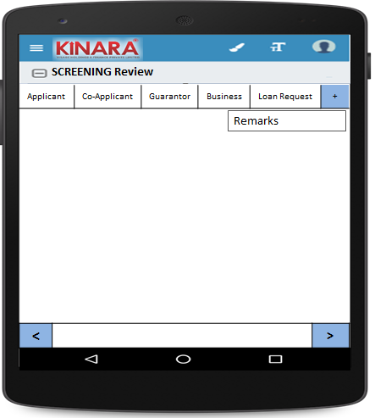

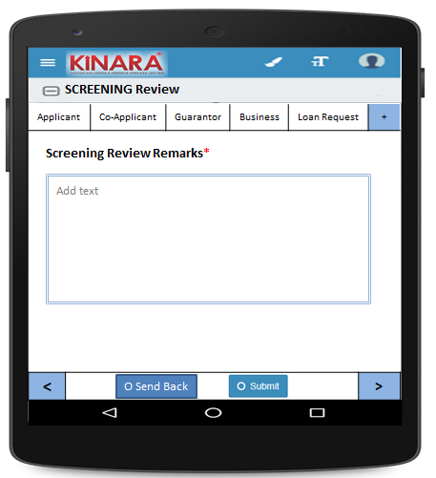

**4.2.1 Applicant**

Screening Review will start with Summary

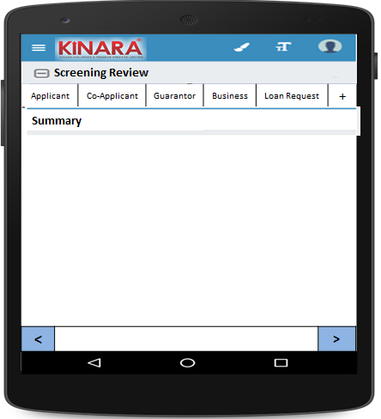

* + - 1. Summary will provide Risk Score & CB Check Report

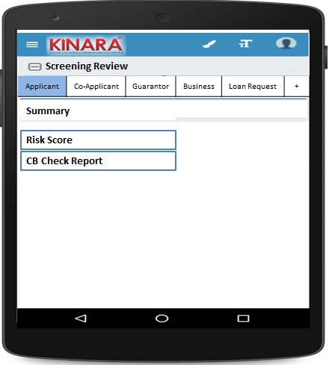

* + - 1. Financial Summary : Risk Score Just display screening score here (Will have to discuss this further)

|  |  |
| --- | --- |
| Page 1 | Page 2 |

* + - 1. CB Check Report will provide Reports for Applicant, Co-applicants & Business

|  |  |
| --- | --- |
| Page 1 | Page 2 |
| Page 3 | Page 4 |

* + - 1. Applicant Details

|  |  |
| --- | --- |
| Page 1 | Page 2 |
| Page 3 | Page 4 |

* + - 1. Address Details

|  |  |
| --- | --- |
| Page 1 | Page 2 |
| Page 3 | Page 4 |

* + - 1. Liabilities

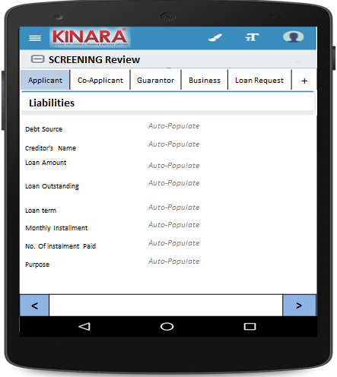

* + - 1. Bank Statement Details

|  |  |
| --- | --- |
| Page 1 | Page 2 |

* + 1. **Co-applicant**

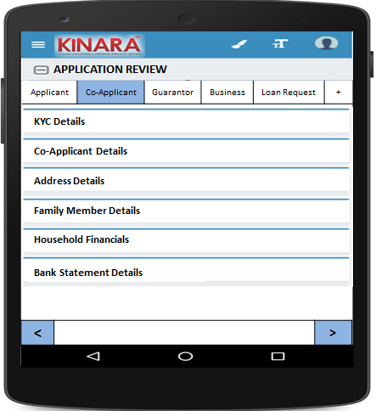

* + - 1. KYC Details

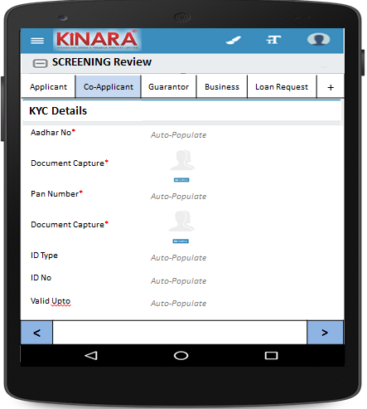

* + - 1. Co-applicant Details

|  |  |  |
| --- | --- | --- |
| Page 1 | Page 2 | Page 3 |

* + - 1. Address Details

|  |  |
| --- | --- |
| Page 1 | Page 2 |
| Page 3 | Page 4 |

* + - 1. Liabilities

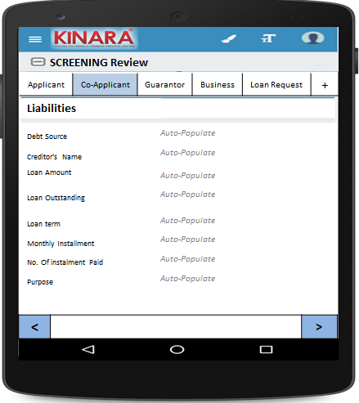

* + - 1. Bank Statement Details

|  |  |
| --- | --- |
| Page 1 | Page 2 |

* + 1. **Guarantor**

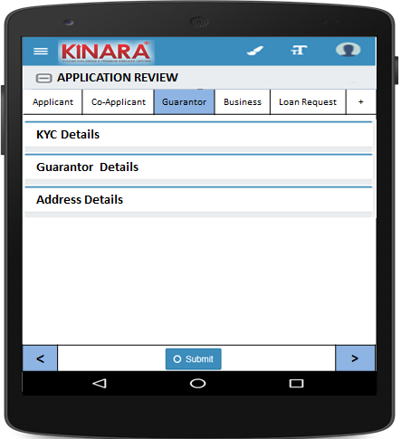

* + - 1. KYC Details

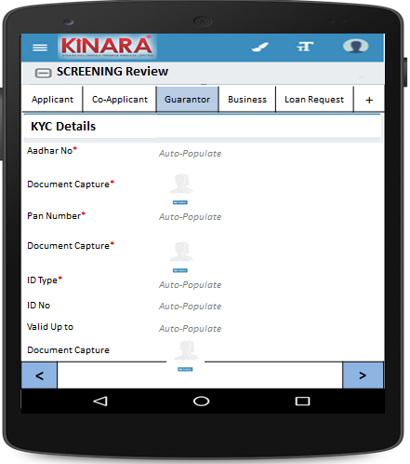

* + - 1. Guarantor Details

|  |  |  |
| --- | --- | --- |
| Page 1 | Page 2 | Page 3 |

* + - 1. Address Details

|  |  |
| --- | --- |
| Page 1 | Page 2 |
| Page 3 | Page 4 |

* + 1. **Business**

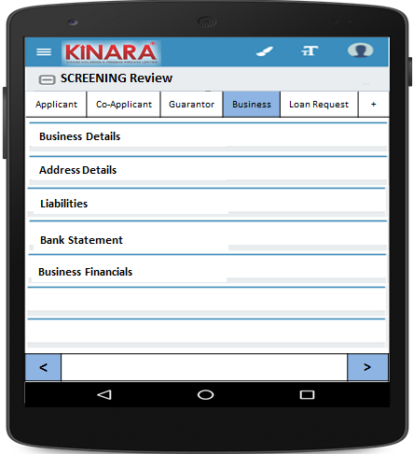

* + - 1. Business Details

|  |  |  |
| --- | --- | --- |
| Page 1 | Page 2 | Page 3 |

* + - 1. Address Details

|  |  |
| --- | --- |
| Page 1 | Page 2 |

* + - 1. Business Financials

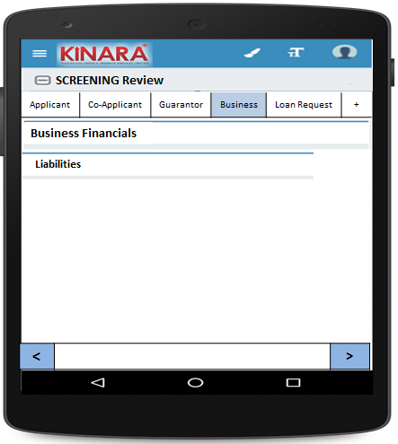

* + - * 1. Liabilities

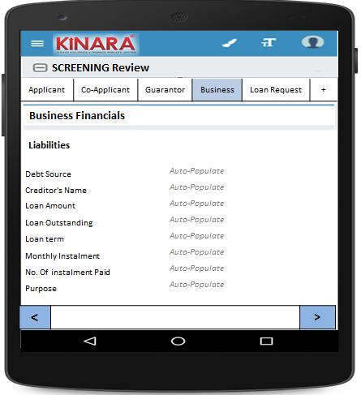

* + - 1. Bank Statement

|  |  |
| --- | --- |
| Page 1 | Page 2 |

* + - 1. Business Financials

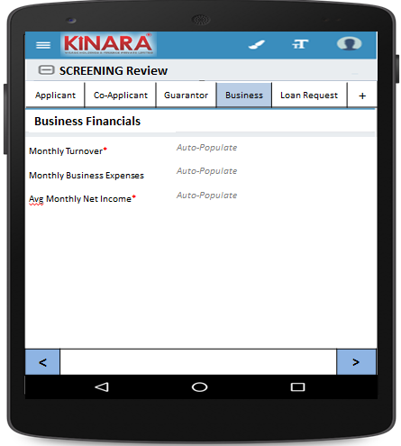

* + 1. **Loan Request**

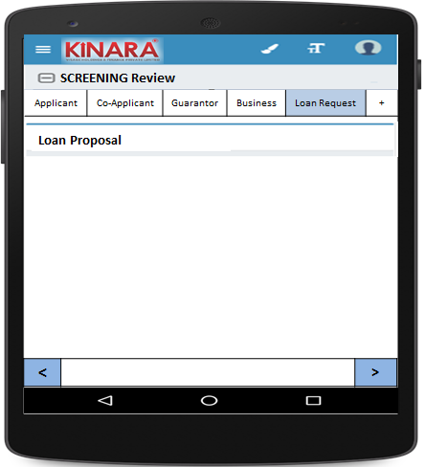

* + - 1. Loan Proposal

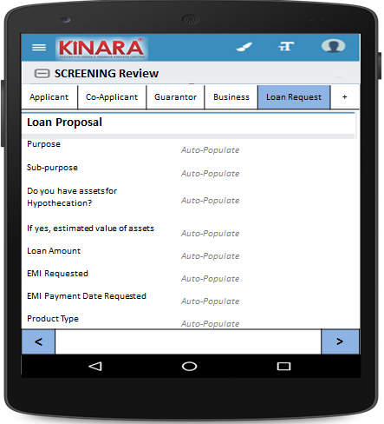

## Functional requirements

* 1. Once the profile is completed from the Screening queue, the Hub Manager reviews the application details data and give remarks. Based on the review s/he can submit and move profile to next stage or send back to screening stage.
  2. All profiles submitted will be sent to application stage.
  3. Uploads

-NA-

## Downloads

-NA-

## Reports

-NA-